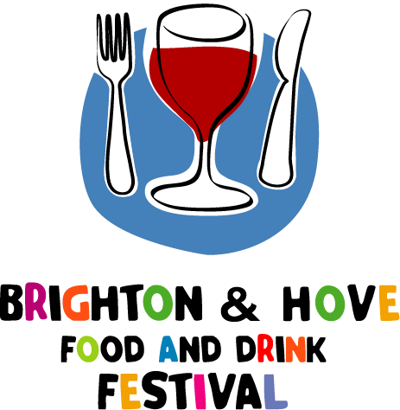

Invitation to support Brighton & Hove Food and Drink Festival 2005

Dear Brighton & Hove business,

We are delighted to invite you to participate in the Brighton & Hove Food and Drink Festival 2005 - a celebration of the best food and drink available locally – from 7th to 30th September.

Yellow Pages is the proud headline sponsor of our third annual festival and we have an exciting line up of events planned, including a huge Festival Food and Drink Market with 100 Sussex producers on 10th and 11th September in the Corn Exchange and along New Road, a Regency Festival Banquet at the Royal Pavilion, the popular and very funky Battle of the Bars and much more.

We hope that you will join in the festival this year.

For just £50, you can become an official supporter of the event with the following benefits:
- an ‘official supporter of Brighton & Hove Food and Drink Festival 2005’ window sticker
- a listing of your business name in the official supporters list to be included in:
- the official festival guide (50,000 copies);
- the official festival website (going live in June);
- and a special supplement in The Argus before the festival

You can also hold your own special event to celebrate food and/or drink during September too. This could be anything from offering a special festival menu or hosting a special talk or tasting to holding a major public event.

If you decide you would like to do this, please send details of your event to info@priory-partnership.co.uk, including details of your event and your contact details and we will include it in our promotion of the festival’s official fringe events and provide you with the festival logo to use on your promotional material.

We hope you will help us make this year’s festival the best ever.

All the best,

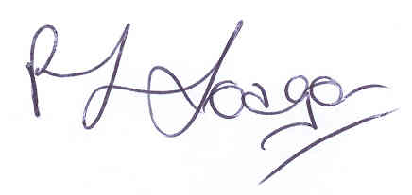
Paula Seager
Festival Director

